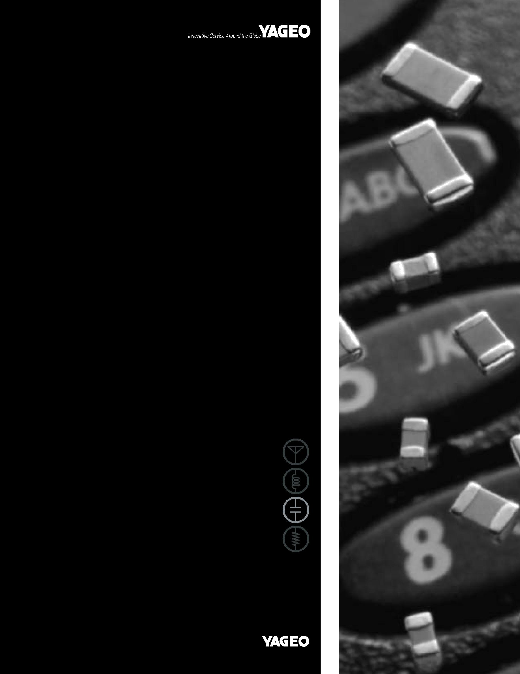

y

DATA SHEET

MULTILAYER CERAMIC CAPACITORS

CC Series

NP0

16V TO 100V

Product Specification – Jul 07, 2004 V.6 Supersedes Date of Mar. 12, 2004

 |  |  |  |  |  | 2
 | Surface Mount Multilayer Ceramic Capacitors | CC | SERIES | NP0, 16V to 100V | 10


SCOPE

This specification describes Yageo CC NP0 series chip capacitors.

ORDERING INFORMATION

Part number is identified by the series, size, tolerance, packing style, temperature coefficient, rated voltage and capacitance value.

CC ⋅ ⋅ ⋅ ⋅ ⋅ ⋅ NPO ⋅ BN ⋅ ⋅ ⋅

(1) (2) (3) (4) (5)

(1) SIZE

0402 (1005)

0603 (1608)

0805 (2012)

1206 (3216)

1210 (3225)

1812 (4832)

(2) TOLERANCE

B = ±0.1pF

C = ±0.25pF

D = ±0.5pF

F = ±1%

G = ±2%

J = ±5%

(3) PACKING STYLE

R = 7” paper tape

K = 7” blister tape

P = 13” paper tape

F = 13” blister tape

C = Bulk case

(4) RATED VOLTAGE

7 = 16V

8 = 25V

9 = 50V

0 = 100V

(5) CAPACITANCE VALUE:

First two for significant figures and 3rd for number of zero

Letter “R” for decimal point

CONSTRUCTION

 | terminations
 | electrodes
Fig. 1 Surface mounted multilayer | MLB457
ceramic capacitor construction | ceramic material

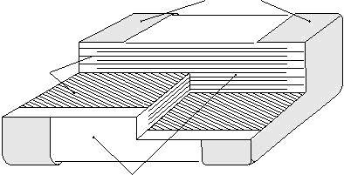

DIMENSION

For dimensions see Table 1
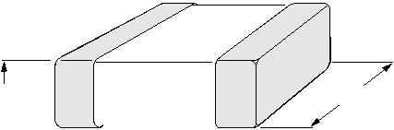

T W

Fig. 2
Fig. 2 | Surface mounted multilayer ceramic |  |  |  |  |  |  |  | L ₂ |  |  | L ₄ |  |  |  | L ₃ |  |  | MBB211
 | capacitor dimension |  |  |  |  |  |  |  |  |  |  |  |  |  |  |  |  |  | MBB211
 |  |  |  |  |  |  |  |  |  |  |  | L ₁
Table 1
TYPE |  | CC0402 | CC0603 | CC0805 |  |  |  |  |  | CC1206 |  |  |  | CC1210 |  |  |  |  |  | CC1812
L1 (mm) |  | 1. 0±0.05 | 1.6±0.10 | 2.0±0.10 |  |  |  |  |  | 3.2±0.15 |  |  |  | 3.2±0.20 |  |  |  |  |  | 4.5±0.20
W (mm) |  | 0.5±0.05 | 0.8±0.07 | 1.25±0.10 |  |  |  |  |  | 1.6±0.15 |  |  |  | 2.5±0.20 |  |  |  |  |  | 3.2±0.20
T (mm) | min. | 0.45 | 0.73 | 0.50 |  |  |  |  |  | 0.50 |  |  |  | 0.50 |  |  |  |  |  | 0.50
T (mm) | max. | 0.55 | 0.87 | 1.35 |  |  |  |  |  | 1.35 |  |  |  | 1.80 |  |  |  |  |  | 1.80
 | min. | 0.15 | 0.20 | 0.25 |  |  |  |  |  | 0.25 |  |  |  | 0.25 |  |  |  |  |  | 0.25
L2/L3 (mm) _{max.} |  | 0.30 | 0.50 | 0.75 |  |  |  |  |  | 0.75 |  |  |  | 0.75 |  |  |  |  |  | 0.75
L4 (mm) | min. | 0.40 | 0.60 | 0.55 |  |  |  |  |  | 1.40 |  |  |  | 1.40 |  |  |  |  |  | 2.20

www.yageo.com Jul 07, 2005 V.6

 |  |  |  |  |  | 3
 | Surface Mount Multilayer Ceramic Capacitors | CC | SERIES | NP0, 16V to 100V | 10

CAPACITANCE RANGE & THICKNESS FOR 16V & 25V

Table 2
CAPACITANCE |  |  | 16V |  | 25V
(pF) |  |  | 0402 | 0603 | 0402 | 0603 | 0805 | 1206 | 1210
150
180 |  |  |  |  | 0.5±0.05
220
270
330 |  |  | 0.5±0.05
390 |  |  | 0.5±0.05
470
560
680
820
1,000 |  |  |  |  |  | 0.8±0.07
1,200 |  |  |  |  |  | 0.8±0.07
1,500
1,800
2,200 |  |  |  | 0.8±0.07
2,700 |  |  |  | 0.8±0.07
3,300 |  |  |  |  |  |  | 0.85±0.1
3,900 |  |  |  |  |  |  | 1.25±0.1
4,700 |  |  |  |  |  |  | 1.25±0.1
5,600
6,800
8,200 |  |  |  |  |  |  |  | 0.85±0.1
10,000 |  |  |  |  |  |  |  | 0.85±0.1
12,000 |  |  |  |  |  |  |  |  | 0.6±0.1
15,000 |  |  |  |  |  |  |  |  | 0.85±0.1
18,000 |  |  |  |  |  |  |  |  | 0.85±0.1
22,000 |  |  |  |  |  |  |  |  | 1.15±0.1

www.yageo.com Jul 07, 2005 V.6

 |  |  |  |  |  | 4
 | Surface Mount Multilayer Ceramic Capacitors | CC | SERIES | NP0, 16V to 100V | 10

CAPACITANCE RANGE & THICKNESS FOR 50V & 100V

Table 3
CAPACITANCE |  |  | 50V |  |  |  |  |  |  |  | 100V
(pF) |  |  | 0402 | 0603 |  | 0805 | 1206 |  | 1210 | 1812 | 0603 |  | 0805 |  |  | 1206 |  | 1210 | 1812
0.47
0.56
0.68
0.82
1.0
1.2
1.5
1.8
2.2
2.7
3.3
3.9
4.7
5.6
6.8
8.2
 |  |  | 0.5±0.05 | 0.8±0.07 |  | 0.6±0.1 | 0.6±0.1
10
12
15
18
22
27
33
39
 |  |  |  |  |  |  |  |  |  |  | 0.8±0.07 |  |  | 0.6±0.1 |  | 0.6±0.1
47 |  |  |  |  |  |  |  |  |  |  | 0.8±0.07 |  |  | 0.6±0.1 |  | 0.6±0.1
56
82
100
120
150


180
220

www.yageo.com Jul 07, 2005 V.6

 |  |  |  |  |  | 5
 | Surface Mount Multilayer Ceramic Capacitors | CC | SERIES | NP0, 16V to 100V | 10

CAPACITANCE RANGE & THICKNESS FOR 50V & 100V (CONT.)

Table 4
CAPACITANCE |  | 50V |  |  |  |  |  | 100V
(pF) |  | 0402 | 0603 | 0805 | 1206 | 1210 | 1812 | 0603 | 0805 |  | 1206 | 1210 | 1812
270
330
390 |  |  | 0.8±0.07 |  |  |  |  | 0.8±0.07
470 |  |  | 0.8±0.07 | 0.6±0.1 |  |  |  | 0.8±0.07
560 |  |  |  | 0.6±0.1 |  |  |  |  | 0.6±0.1
680
820 |  |  |  |  | 0.6±0.1 |  |  |  |  |  | 0.6±0.1
1,000
1,200
1,500 |  |  |  | 0.85±0.1 |  |  |  |  |  | 0.85±0.1
1,800
2,200 |  |  |  | 1.25±0.1 |  | 0.6±0.1 |  |  | 1.25±0.1
2,700 |  |  |  | 1.25±0.1
3,300
3,900 |  |  |  |  | 0.85±0.1 |  |  |  |  |  | 0.85±0.1
4,700 |  |  |  |  |  |  | 0.6±0.1
5,600 |  |  |  |  | 1.15±0.1 |  |  |  |  |  | 1.15±0.1
6,800 |  |  |  |  | 1.15±0.1 | 0.85±0.1 |  |  |  |  | 1.15±0.1
8,200 |  |  |  |  |  | 0.85±0.1 |  |  |  |  |  | 0.85±0.1
10,000 |  |  |  |  |  |  |  |  |  |  |  | 0.85±0.1
12,000 |  |  |  |  |  |  | 0.85±0.1 |  |  |  |  |  | 0.85±0.1
15,000 |  |  |  |  |  |  | 0.85±0.1 |  |  |  |  |  | 0.85±0.1
18,000 |  |  |  |  |  |  | 1.15±0.1 |  |  |  |  |  | 1.15±0.1
22,000 |  |  |  |  |  |  | 1.15±0.1 |  |  |  |  |  | 1.15±0.1

www.yageo.com Jul 07, 2005 V.6

 |  |  |  |  |  | 6
 | Surface Mount Multilayer Ceramic Capacitors | CC | SERIES | NP0, 16V to 100V | 10

THICKNESS CLASSES AND PACKING QUANTITY

Table 5
THICKNESS |  | 8mm TAPE WIDTH / AMOUNT PER REEL |  |  |  | 12mm TAPE WIDTH /
CLASSIFICATION |  |  |  |  |  | AMOUNT PER REEL | AMOUNT PER BULK CASE
(mm) |  | Ø180mm, 7” |  | Ø330mm, 13” |  | Ø180mm, 7” Blister
 |  | Paper | Blister | Paper | Blister | 1812 | 0402 |  | 0603 | 0805
0.5±0.05 | 10,000 |  | --- | 50,000 | --- | --- | 50,000 | --- |  | ---
0.6±0.1 | 4,000 |  | --- | 20,000 | --- | --- | --- | --- |  | 10,000
0.8±0.07 | 4,000 |  | --- | 15,000 | --- | --- | --- | 15,000 |  | ---
0.85±0.1 | 4,000 |  | --- | 15,000 | --- | --- | --- | --- |  | 8,000
1.15±0.1 | --- |  | 3,000 | --- | 10,000 | --- | --- | --- |  | ---
1.25±0.1 | --- |  | 3,000 | --- | 10,000 | --- | --- | --- |  | 5,000

ELECTRICAL CHARACTERISTICS

Table 6
CHARACTERISTICS | TEST CONDITIONS | REQUIREMENT
Operation temperature range | --- | –55°C to +125°C
Temperature characteristic/coefficient (TC) | With respect to 20°C within operation | NP0=16V, 0±60ppm/K
Temperature characteristic/coefficient (TC) | temperature range | NP0>16V, 0±30ppm/K

With respect to 20°C

Capacitance tolerance C≤1000pF 1Vrms/1MHz C>1000pF 1Vrms/1KHz

C<5; ±0.1pF, ±0.25pF

C≥5; ±0.25pF, ±0.5pF

C≥10pF; ±2%, ±5%

 | With respect to 20°C | C<10pF
 | With respect to 20°C | D.F. ≤10(3/C+0.7) x10-4
Dissipation factor (D.F.) | C≤1,000pF 1Vrms/1MHz | D.F. ≤10(3/C+0.7) x10-4
Dissipation factor (D.F.) | C≤1,000pF 1Vrms/1MHz | or 30x10-4 whichever is less
 | C>1,000pF 1Vrms/1KHz | or 30x10-4 whichever is less
 | C>1,000pF 1Vrms/1KHz | C≥10pF, D.F. ≤10x10-4
Insulation resistance (IR) | At U_{r} (rated voltage) for 1 minute | R_{ins} >10GΩ or R_{ins} x C≥500s
Insulation resistance (IR) | U_{r} >500V, at 500V(DC) for 1minute | whichever is less
Dielectric withstanding Voltage | At 2.5x U_{r} (for U_{r} ≤100V) | No breakdown
Dielectric withstanding Voltage | 1.5x U_{r} +100V (for U_{r} >100V) for 5sec | No breakdown

www.yageo.com Jul 07, 2005 V.6

 |  |  |  |  |  | 7
 | Surface Mount Multilayer Ceramic Capacitors | CC | SERIES | NP0, 16V to 100V | 10

TAPING REEL

Table 7
TAPE WIDE | 8mm | 8mm | 12mm |  | T
ØA (mm) | 180 | 330 | 180
ØB (mm) | 62±1.5 | 62±1.5 | 62±1.5
ØD (mm) | 20.5 | 20.5 | 20.5 | D | CBA
ØC (mm) | 12.75±0.15/–0 | 12.75±0.15/–0 | 12.75±0.15/–0
W (mm) | 8.4+1.5/–0 | 8.4+1.5/–0 | 12.4+2/–0
Tmax (mm) | 14.4 | 14.4 | 18.4 |  | MSA284_b
 |  |  |  |  | W
 |  |  |  | Fig. 3 Reel dimension | For dimension see Table 7
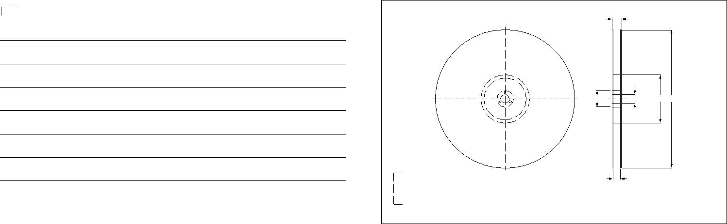

PAPER TAPE SPECIFICATION

Table 8 |  |  |  |  |  | For dimension see Table 8
DIMENSION | 0402 | 0603 | 0805 | 1206 |  |  |  |  |  |  |  |  |  |  |  |  |  |  |  |  |  |  |  |  |  |  |  |  |  |  |  |  |  |  |  |  |  | P₀
A (mm) | 0.62±0.05 | 1.10±0.05 | 1.65±0.05 | 2.0±0.1 |  |  | T |  |  |  |  |  |  |  |  |  | D ₀ |  |  |  |  |  |  |  |  |  |  |  |  |  |  |  |  |  | P₂
B (mm) | 1.12±0.05 | 1.90±0.05 | 2.4±0.05 | 3.5±0.1 |  |  |  |  |  |  |  |  |  |  |  |  |  |  |  |  |  |  |  |  |  |  |  |  |  |  |  |  |  |  |  |  |  |  |  | E
W (mm) | 8.0±0.2 | 8.0±0.2 | 8.0±0.2 | 8.0±0.2
 |  |  |  |  | cover tape |  |  |  |  |  |  |  |  |  |  |  |  |  |  |  |  |  |  |  |  |  |  |  |  |  |  |  |  |  |  |  |  |  |  |  |  |  |  |  |  |  |  |  |  |  | F
E (mm) | 1.75±0.1 | 1.75±0.1 | 1.75±0.1 | 1.75±0.1 |  |  |  |  |  |  |  |  |  |  |  |  |  |  |  |  |  |  |  |  |  |  |  |  |  |  |  |  |  |  |  |  |  |  |  |  |  |  |  |  |  |  |  |  |  |  |  |  |  |  |  |  |  | W
F (mm) | 3.5±0.05 | 3.5±0.05 | 3.5±0.05 | 3.5±0.05 |  |  |  |  |  |  |  |  |  |  |  |  |  |  |  |  |  |  |  |  |  |  |  |  |  |  |  |  |  |  |  |  |  |  |  |  |  |  |  |  |  |  |  |  |  |  |  |  |  | B
 |  |  |  |  |  |  |  |  |  |  |  |  |  |  |  |  |  |  |  |  |  |  |  |  |  |  |  |  |  |  |  |  | A |  |  |  |  |  |  |  |  | ^{P}1 |  |  |  |  |  |  |  |  |  |  |  |  |  | MBG251_a
P0 (mm) | 4±0.05 | 4±0.05 | 4±0.05 | 4±0.05
P1 (mm) | 2±0.05 | 4±0.1 | 4±0.1 | 4±0.1 |  | Fig. 4 |  |  |  |  |  | Paper tape dimension
P2 (mm) | 2±0.05 | 2±0.05 | 2±0.05 | 2±0.05
ØD0 (mm) | 1.5+0.1 | 1.5+0.1 | 1.5+0.1/–0 | 1.5+0.1/–0
T (mm) | 0.6±0.05 | 0.95±0.05 | 0.95±0.05 | 0.95±0.05
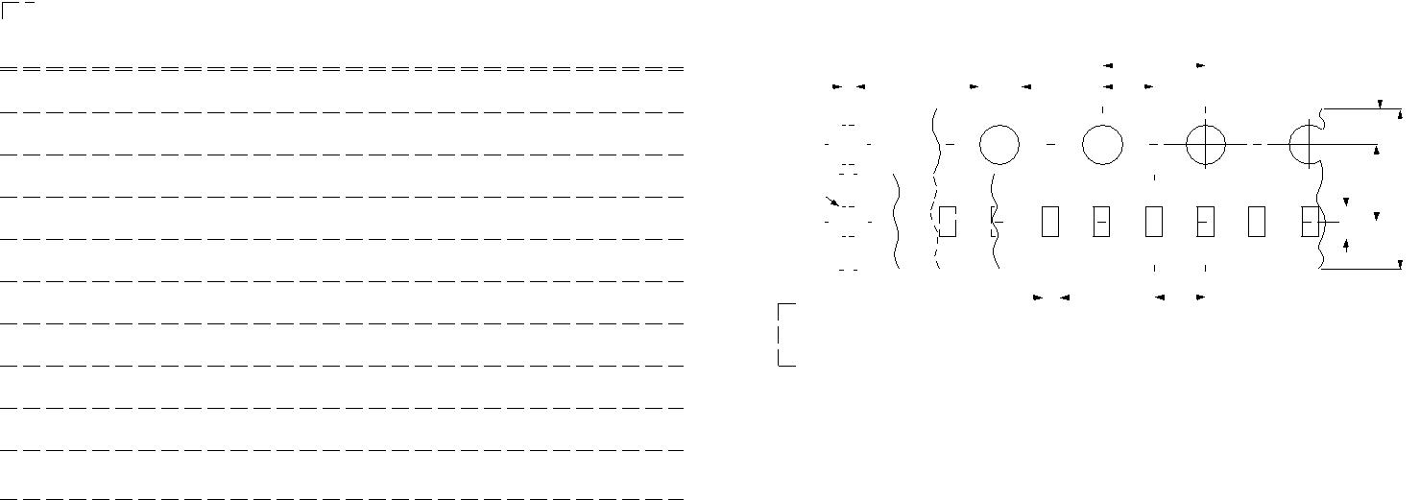

BLISTER TAPE SPECIFICATION

Table 9 |  |  |  |  | For dimension see Table 9
DIMENSION | 0805 | 1206 | 1210 | 1812 | For dimension see Table 9
A (mm) | 0.20 | 0.30 | 0.30 | 0.40 |  | P₀
 |  |  |  |  | D ₀ | P₂
B (mm) | 0.20 | 0.30 | 0.30 | 0.40 |  | E
W (mm) | 8.1±0.2 | 8.1±0.2 | 8.1±0.2 | 12.0±0.2 | pe | F
 |  |  |  |  | pe | W
E (mm) | 1.75±0.1 | 1.75±0.1 | 1.75±0.1 | 1.75±0.1 |  | W
 |  |  |  |  |  | B
F (mm) | 3.5±0.05 | 3.5±0.05 | 3.5±0.05 | 5.5±0.05
P0 (mm) | 4±0.1 | 4±0.1 | 4±0.1 | 4±0.1 |  | MBG516_a
 |  |  |  |  | A | D ₁
P1 (mm) | 4±0.1 | 4±0.1 | 4±0.1 | 8±0.1 | T | P₁
P2 (mm) | 2±0.05 | 2±0.05 | 2±0.05 | 2±0.05 | direction of unreeling
ØD0 (mm) | 1.5+0.1/–0 | 1.5+0.1/–0 | 1.5+0.1/–0 | 1.5+0.1/–0 | Fig. 5 Leader/trailer tape dimension
Tmax (mm) | 3.5 | 3.5 | 3.5 | 3.5
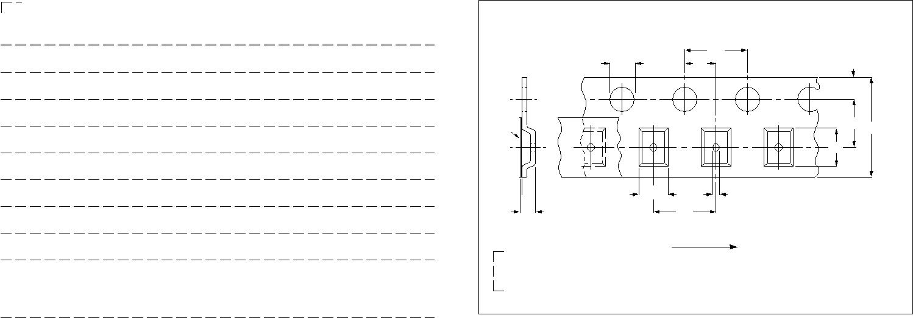

www.yageo.com Jul 07, 2005 V.6

 |  |  |  |  |  | 8
 | Surface Mount Multilayer Ceramic Capacitors | CC | SERIES | NP0, 16V to 100V | 10

PACKING METHOD

LEADER/TRAILER TAPE SPECIFICATION

 |  |  |  |  |  |  |  |  |  |  |  |  |  |  |  |  |  | leader end
 |  |  |  |  |  |  |  |  |  |  |  |  |  |  |  |  |  |  |  |  | cover tape only
trailer end |  |  |  |  |  |  |  |  |  |  |  |  |  |  |  | empty compartments |  |  |  |  |  | 120 40 mm
 |  |  |  |  |  |  |  |  |  |  |  |  |  |  |  | with cover tape
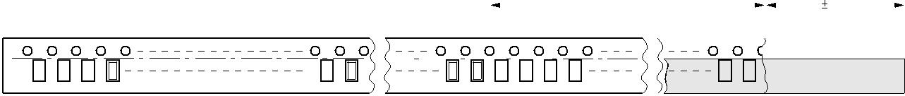

 |  | trailer (max. 260 mm) |  |  |  | leader 400 mm
 |  | trailer (max. 260 mm) |  |  |  | leader 400 mm | MEA529 - 2
Fig. 6 Leader and trailer tape dimension

METHOD OF MOUNTING

For normal use the capacitors may be mounted on printed-circuit boards or ceramic substrates by applying wave soldering, reflow soldering (including vapor phase soldering) or conductive adhesive in accordance with CECC 00802 classification A.

Typical values (sold line)

Process limits (dotted lines)

300 |  | 10 s | MLA859
T |  | 10 s | MLA859
(¡C) | 260 ¡C
250 | 245 ¡C
 | 215 ¡C | 10 s
200 |  | 40 s
 | 180 ¡C | 40 s
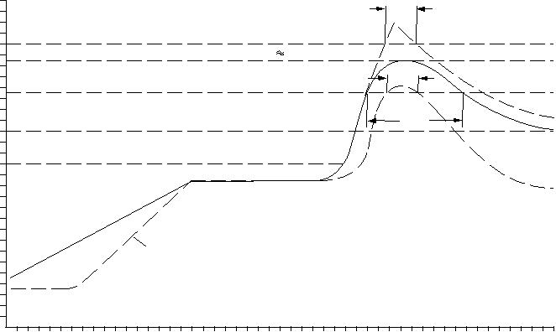

150
130 ¡C

100

2 K/s

50

0

0 50 100 150 200 250 t (s)

Fig. 7 Recommended reflow soldering profile

Typical values (sold line)
Process limits (dotted lines)
The capacitors may be soldered twice in accordance with this method if desired

300
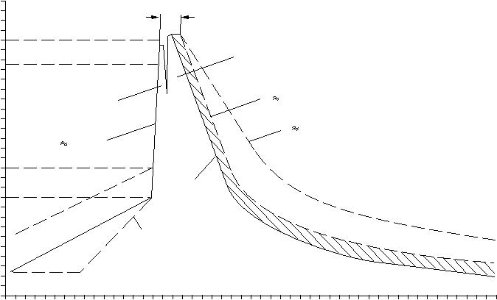
10 s
T |  |  |  |  | MLA861
(¡C) |  |  |  |  | MLA861
250 | 235 ¡C to 260 ¡C |  | second wave
200 | first wave |  | 5 K/s
 |  |  | 2 K/s
150 | 200 K/s
 | 100 ¡C to 130 ¡C | forced
100 |  | forced
100 |  | cooling
50 |  | 2 K/s
0
0 | 50 | 100 | 150 | 200 | t (s) | 250

Fig. 8 Recommended wave soldering profile.

www.yageo.com Jul 07, 2005 V.6

 |  |  |  |  |  | 9
 | Surface Mount Multilayer Ceramic Capacitors | CC | SERIES | NP0, 16V to 100V | 10

TEST AND REQUIREMENT

Table 10
IEC384-10 | TEST ITEMS | CONDITIONS | REQUIREMENTS
4.9 | Bending | Bending rate 1mm/s, jig. radius 340mm | l∆C/Cl ≤1%
4.10 | Resistance to soldering heat | 260±5°C for 10±0.5s in static solder bath | l∆C/Cl within 0.5% or 0.5pF
4.10 | Resistance to soldering heat | 260±5°C for 10±0.5s in static solder bath | whichever is greater
4.11 | Solderability | 235±5°C for 2±0.5s in a static solder bath | The termination shall be well tinned
4.12 | Rapid change of temperature | –55°C to +125°C, 5 cycles | l∆C/Cl within 1% or 1pF, whichever is
4.12 | Rapid change of temperature | –55°C to +125°C, 5 cycles | greater
 |  |  | l∆C/Cl within 2% or 1pF whichever is
4.14 | Damp heat | At 40°C, 90 to 95% RH | greater
4.14 | Damp heat | and Ur applied for 500 hours | D.F. ≤2xspecified value
 |  |  | IR≥2,500MΩ or RxC≥25s, whichever is less
 |  | At upper category temperature | l∆C/Cl within 2% or 1pF whichever is
 |  | At upper category temperature | greater
4.15 | Endurance | 2x Ur applied (1.5x Ur for Ur >50V) | greater
4.15 | Endurance | 2x Ur applied (1.5x Ur for Ur >50V) | D.F. ≤2xspecified value
for 1,000 hours

www.yageo.com Jul 07, 2005 V.6

 |  |  |  |  | 10
 | Surface Mount Multilayer Ceramic Capacitors | CC | SERIES | NP0, 16V to 100V |  | 10

REVISION HISTORY

REVISION | DATE | CHANGE NOTIFICATION | DESCRIPTION
Version 06 | Jul 07, 2005 | - | - Thickness updated
Version 05 | Mar 12, 2004 | - | - Thickness and packing quantity amending
Version 04 | Aug. 13, 2003 | - | - Taping drawing amended
Version 03 | Dec. 03, 2002 | - | - New Yageo edition
Version 02 | Jul. 04, 2002 | - | -
Version 01
Version 0 |  |  | - First issue of this specification

www.yageo.com Jul 07, 2005 V.6

